Tableau - Basic Filters

Filtering is the process of removing certain values or range of values from a result set. Tableau filtering feature allows both simple scenarios using field values as well as advanced calculation or context-based filters. In this chapter, you will learn about the basic filters available in Tableau.

There are three types of basic filters available in Tableau. They are as follows −

* **Filter Dimensions** are the filters applied on the dimension fields.
* **Filter Measures** are the filters applied on the measure fields.
* **Filter Dates** are the filters applied on the date fields.

## Filter Dimensions

These filters are applied on the dimension fields. Typical examples include filtering based on categories of text or numeric values with logical expressions greater than or less than conditions.

### Example

We use the Sample - Superstore data source to apply dimension filters on the sub-category of products. We create a view for showing profit for each sub-category of products according to their shipping mode. For it, drag the dimension field “Sub-Category” to the Rows shelf and the measure field “profit” to the Columns shelf.

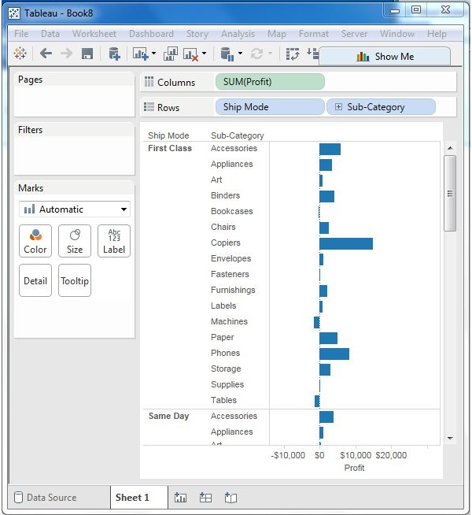

Next, drag the Sub-Category dimension to the Filters shelf to open the Filter dialog box. Click the None button at the bottom of the list to deselect all segments. Then, select the Exclude option in the lower right corner of the dialog box. Finally, select Labels and Storage and then click OK. The following screenshot shows the result with the above two categories excluded.

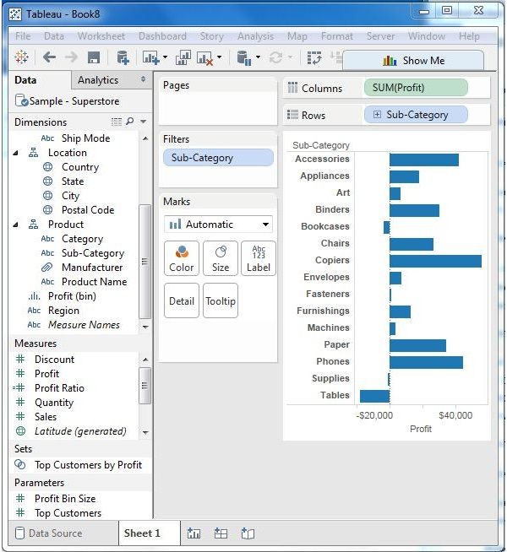

## Filter Measures

These filters are applied on the measure fields. Filtering is based on the calculations applied to the measure fields. Hence, while in dimension filters you use only values to filter, in measures filter you use calculations based on fields.

### Example

You can use the Sample - Superstore data source to apply dimension filters on the average value of the profits. First, create a view with ship mode and subcategory as dimensions and Average of profit as shown in the following screenshot.

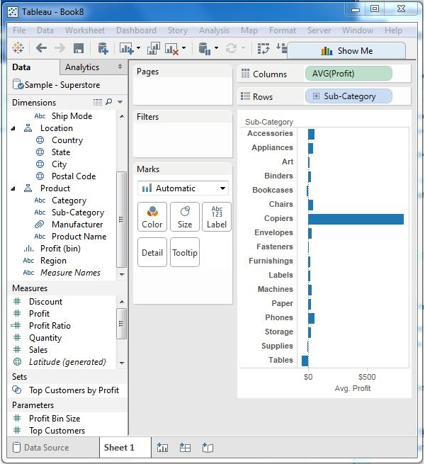

Next, drag the AVG (profit) value to the filter pane. Choose Average as the filter mode. Next, choose "At least" and give a value to filter the rows, which meet these criteria.

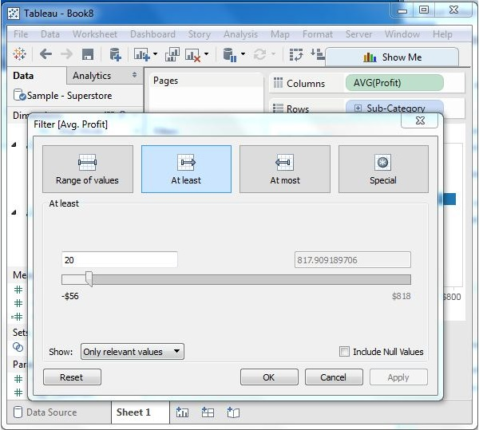

After completion of the above steps, we get the final view below showing only the subcategories whose average profit is greater than 20.

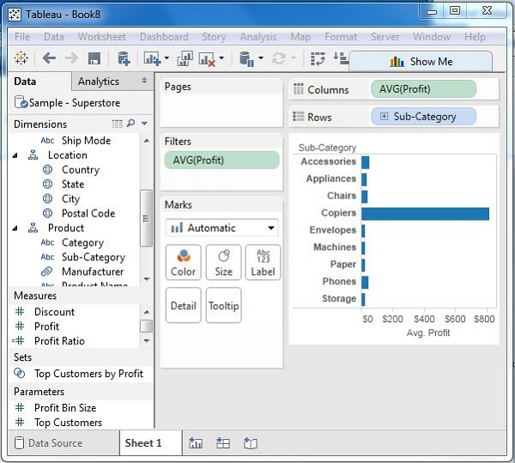

## Filter Dates

Tableau treats the date field in three different ways while applying the date field. It can apply filter by taking a relative date as compared to today, an absolute date, or range of dates. Each of this option is presented when a date field is dragged out of the filter pane.

### Example

We choose the sample - Superstore data source and create a view with order date in the column shelf and profit in the rows shelf as shown in the following screenshot.

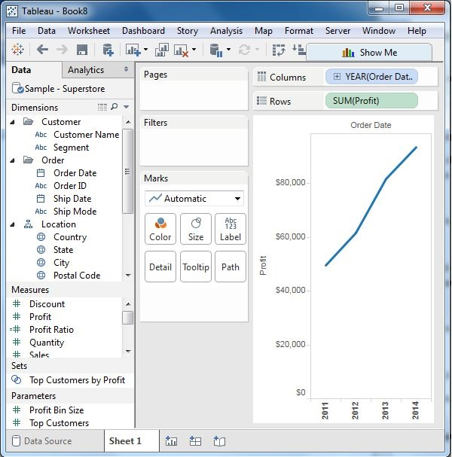

Next, drag the "order date" field to the filter shelf and choose Range of dates in the filter dialog box. Choose the dates as shown in the following screenshot.

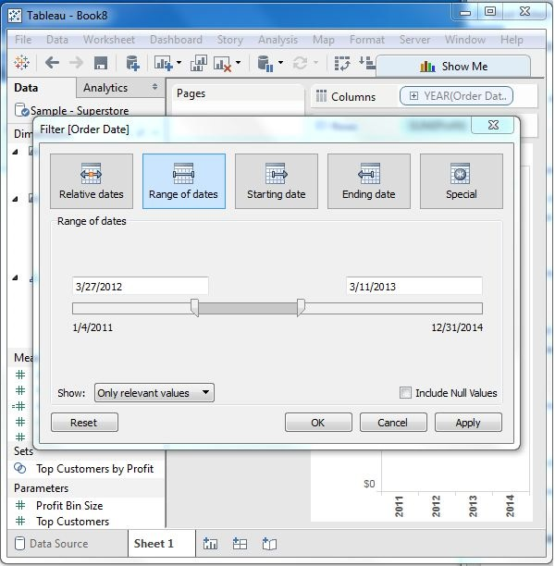

On clicking OK, the final view appears showing the result for the chosen range of dates as seen in the following screenshot.

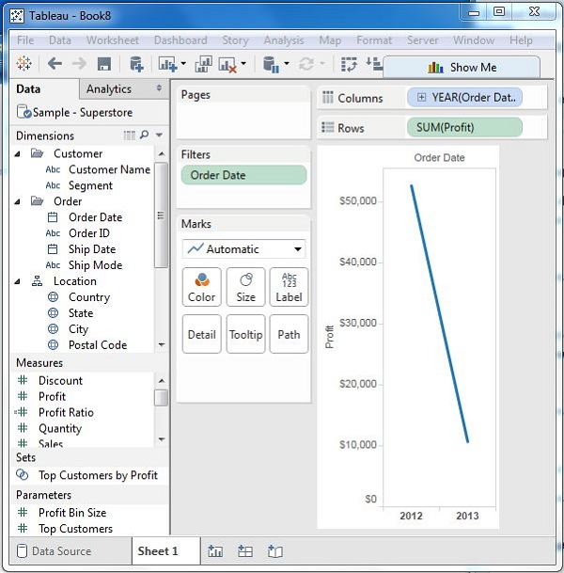

# Tableau - Quick Filters

Many filter types in Tableau are quickly available using the right-click option on the dimension or measure. These filters known as Quick filters have enough functionality to solve most of the common filtering needs.

The following screenshot shows how the quick filters are accessed.

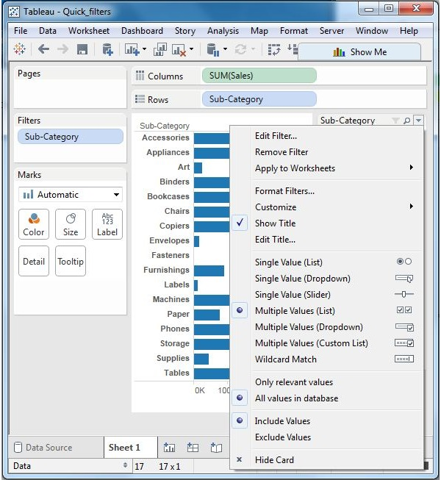

Following is a list of various quick filters and their use.

|  |  |
| --- | --- |
| **Filter name** | **Purpose** |
| **Single Value (List)** | Select one value at a time in a list. |
| **Single Value (Dropdown)** | Select a single value in a drop-down list. |
| **Multiple Values (List)** | Select one or more values in a list. |
| **Multiple Values (Dropdown)** | Select one or more values in a drop-down list. |
| **Multiple Values (Custom List)** | Search and select one or more values. |
| **Single Value (Slider)** | Drag a horizontal slider to select a single value. |
| **Wildcard Match** | Select values containing the specified characters. |

### Example

Consider the Sample-Superstore data source to apply some quick filters. In the following example, choose sub-category as the row and sales as the column which by default produces a horizontal bar chart. Next, drag the sub-category field to the filters pane. All the subcategories appear next to the chart. Apply wildcard filtering using the expression **a\*** which selects all subcategory name starting with **“a”**.

The below screen shows the result of applying this filter where only the sub-categories starting with **“A”** are displayed.

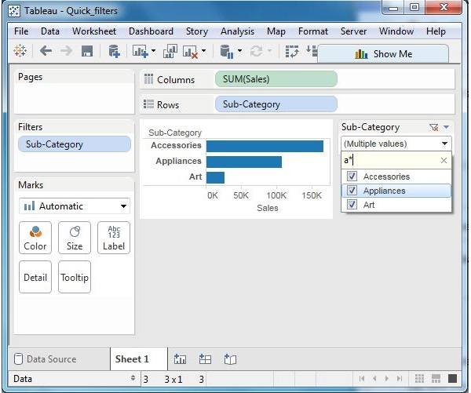

## Clearing the Filter

Once the analysis is complete by applying the filter, remove it by using the clear filter option. For this, go to the filter Pane, right-click on the field name and choose Clear Filter as shown in the following screenshot.

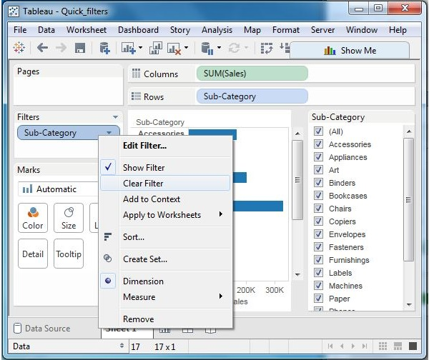

# Tableau - Context Filters

The normal filters in Tableau are independent of each other. It means each of the filter reads all the rows from the source data and creates its own result. However, there may be scenarios where you might want the second filter to process only the records returned by the first filter. In such a case, the second filter is known as dependent filters because they process only the data that passes through the context filter. Context Filters serve two main purposes.

* **Improves performance** − If you set a lot of filters or have a large data source, the queries can be slow. You can set one or more context filters to improve the performance.
* **Creates a dependent numerical or top N filter** − You can set a context filter to include only the data of interest, and then set a numerical or a top N filter.

## Creating Context Filter

Using the Sample-superstore, find the top 10 Sub-Category of products for the category called Furniture. To achieve this objective, following are the steps.

**Step 1** − Drag the dimension Sub-Category to the Rows shelf and the measure Sales to the Columns Shelf. Choose the horizontal bar chart as the chart type. Drag the dimension Sub-Category again to the Filters shelf. You will get the following chart.

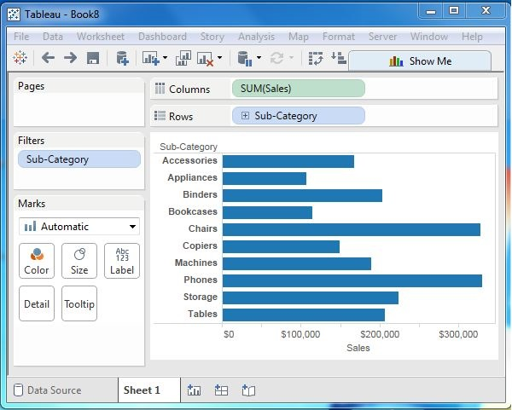

**Step 2** − Right-click on the field Sub-Category in the filter shelf and go the fourth tab named Top. Choose the option by field. From the next drop-down, choose the option Top 10 by Sales Sum as shown in the following screenshot.

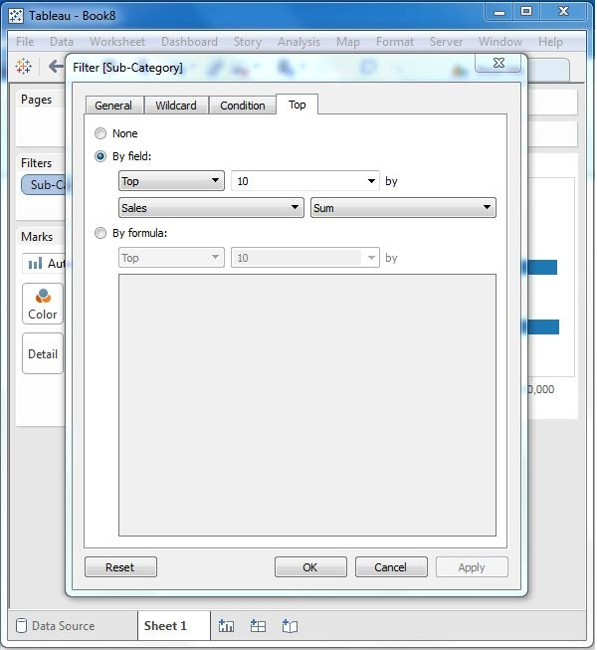

**Step 3** − Drag the dimension Category to the filter shelf. Right-click to edit and under the general tab choose Furniture from the list. As you can see the result shows three subcategory of products.

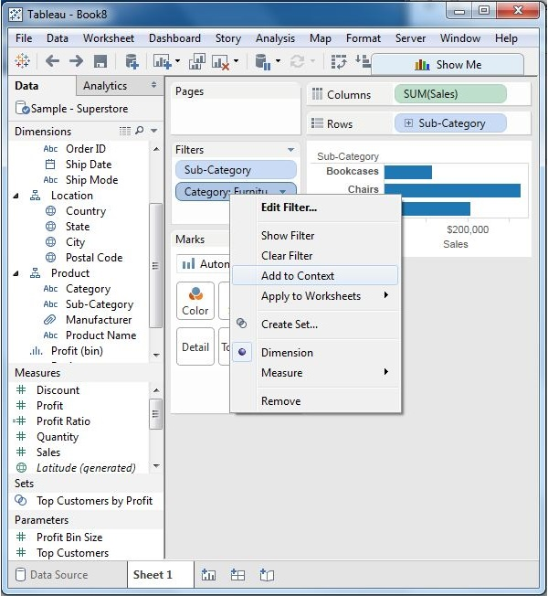

**Step 4** − Right-click the Category: Furniture filter and select the option Add to Context. This produces the final result, which shows the subcategory of products from the category Furniture which are among the top 10 subcategories across all the products.

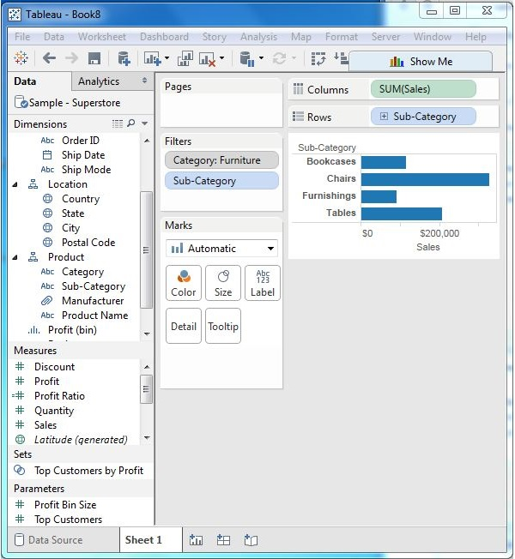

# Tableau - Condition Filters

One of the important filtering options in Tableau is to apply some conditions to already existing filters. These conditions can be very simple like finding only those sales which are higher than a certain amount or it can be a complex one based on a certain formula. The conditions can also be applied to create a range filter.

## Creating a Condition Filter

Using the Sample-superstore, let's find that sub-category of products across all segments whose sales exceed one million. To achieve this objective, following are the steps.

**Step 1** − Drag the dimension segment and the measure Sales to the Column shelf. Next, drag the dimension Sub-Category to the Rows shelf. Choose the horizontal bar chart option. You will get the following chart.

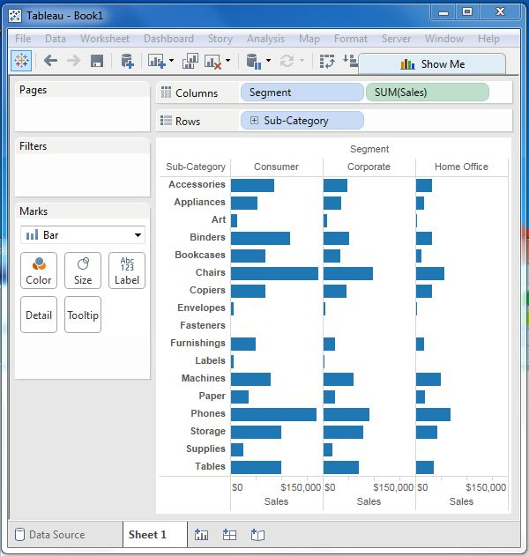

**Step 2** − Drag the dimension Sub-Category to the Filters Shelf. Right-click to edit and go to the tab Condition. Here, choose the radio option by field. From the drop-down, select Sales, Sum and greater than equal to symbol specifying the value 100000.

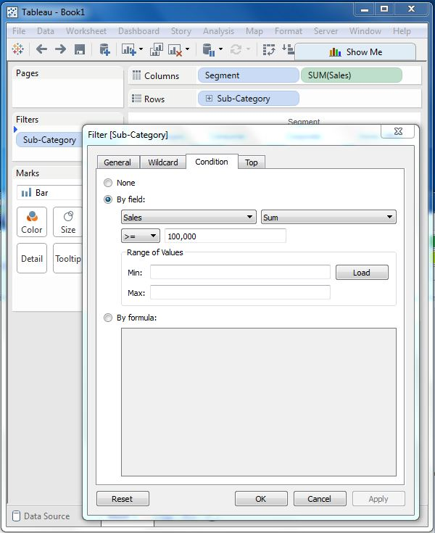

On completion of the above two steps, we get a chart which shows only those subcategory of products, which have the required amount of sale. Also this is shown for all the available segments where the condition is met.

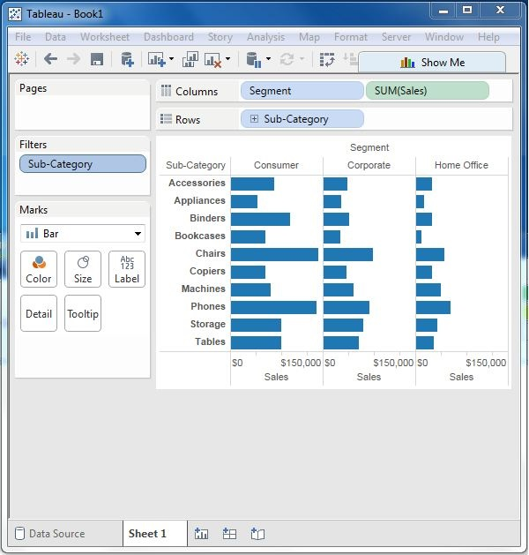

# Tableau - Top Filters

The Top option in Tableau filter is used to limit the result set from a filter. For example, from a large set of records on sales you want only the top 10 values. You can apply this filter using the inbuilt options for limiting the records in many ways or by creating a formula. In this chapter, you will explore the inbuilt options.

## Creating a Top Filter

Using the Sample-superstore, find the sub-category of products which represents the top 5 sales amount. To achieve this objective, following are the steps.

**Step 1** − Drag the dimension Sub-Category to the Rows shelf and the Measure Sales to the Columns shelf. Choose the horizontal bar as the chart type. Tableau shows the following chart.

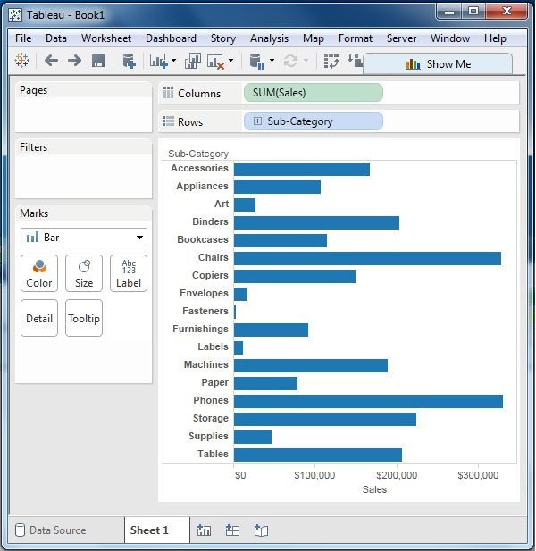

**Step 2** − Right-click on the field Sub-Category and go to the tab named Top. Here, choose the second radio option by field. From the drop-down, choose the option Top 5 by Sum of Sales.

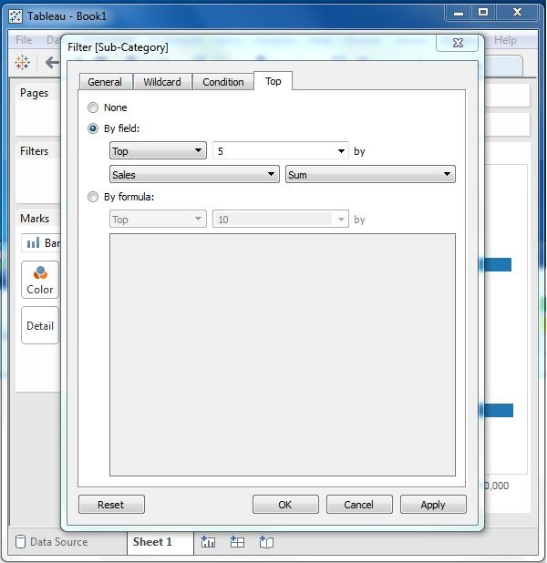

On completion of the above step, you will get the following chart, which shows the top 5 Sub-Category of products by sales.

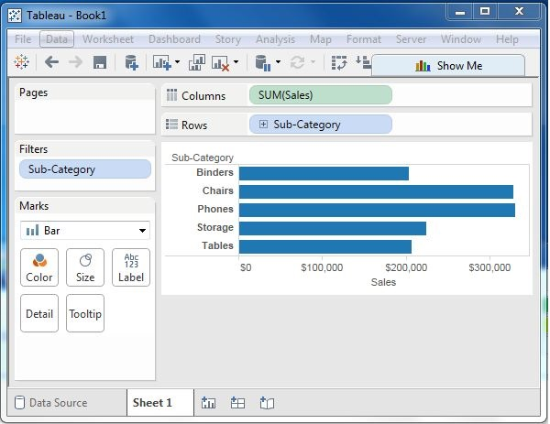

# Tableau - Filter Operations

Any data analysis and visualization work involves the use of extensive filtering of data. Tableau has a very wide variety of filtering options to address these needs. There are many inbuilt functions for applying filters on the records using both dimensions and measures. The filter option for measures offers numeric calculations and comparison. The filter option for dimension offers choosing string values from a list or using a custom list of values. In this chapter, you will learn about the various options as well as the steps to edit and clear the filters.

## Creating Filters

Filters are created by dragging the required field to the Filters shelf located above the Marks card. Create a horizontal bar chart by dragging the measure sales to the Columns shelf and the dimension Sub-Category to the Rows shelf. Again drag the measure sales into the Filters shelf. Once this filter is created, right-click and choose the edit filter option from the pop-up menu.

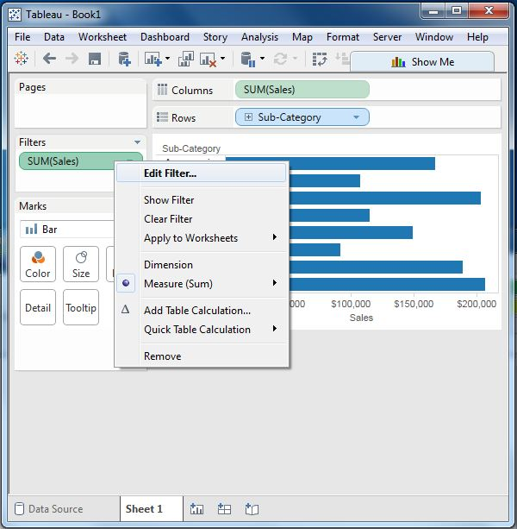

### Creating Filters for Measures

Measures are numeric fields. So, the filter options for such fields involve choosing values. Tableau offers the following types of filters for measures.

* **Range of Values** − Specifies the minimum and maximum values of the range to include in the view.
* **At Least** − Includes all values that are greater than or equal to a specified minimum value.
* **At Most** − Includes all values that are less than or equal to a specified maximum value.
* **Special** − Helps you filter on Null values. Include only Null values, Non-null values, or All Values.

Following worksheet shows these options.

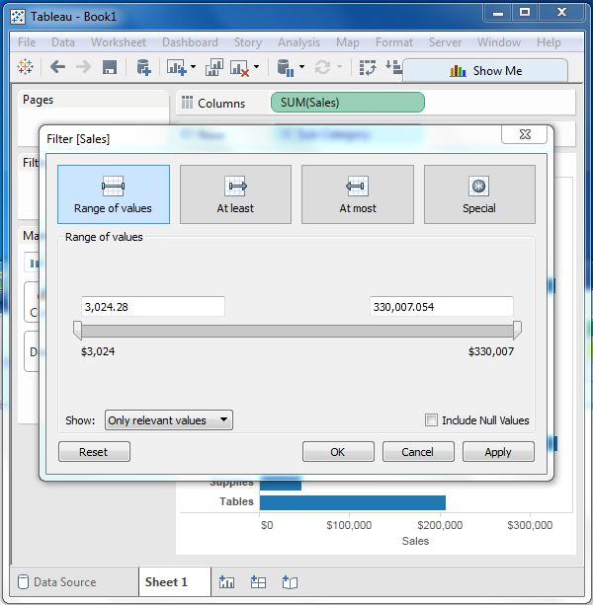

### Creating Filters for Dimensions

Dimensions are descriptive fields having values which are strings. Tableau offers the following types of filters for dimensions.

* **General Filter** − allows to select specific values from a list.
* **Wildcard Filter** − allows to mention wildcards like **cha\*** to filter all string values starting with **cha**.
* **Condition Filter** − applies conditions such as sum of sales.
* **Top Filter** − chooses the records representing a range of top values.

Following worksheet shows these options.

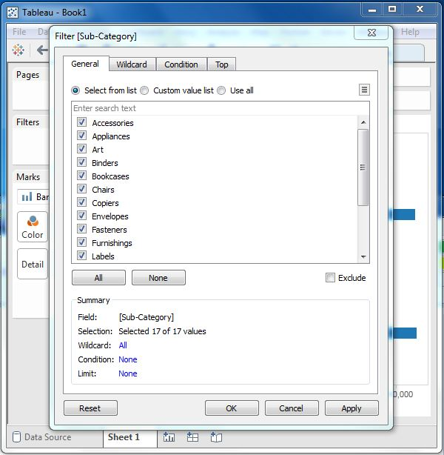

## Clearing Filters

Filters can be easily removed by choosing the clear filter option as shown in the following screenshot.

